

Maths

Entry Examination

60 Minutes

Name: …………………………………..…

Current School: …………………………...

**Please read this information before the examination starts.**

* *You may not use a calculator.*
* *You should attempt all questions.*
* *There are 33 questions.*
* *Use the space provided on the question paper for your workings.*
* *Make sure that there is only one final answer, which is written clearly.*

|  |  |
| --- | --- |
| **1)** Work out       a) 8.002 $+$  10.421  ………………………       b) 6.91 $-$  0.13  ………………………       c) 0.2 $×$  5.39  ……………………… | [4] |
| d) 9 $÷$  0.2  ……………………… |  |
|  |  |
| **2)** Calculate the following and give your answer as a fraction in its lowest terms       a) $\frac{7}{16}+\frac{3}{20}$ ………………………       b) $\frac{7}{8}$ $×$ $\frac{2}{15}$……………………… | [2] |
|  |  |
| **3)** Work out the following, $\frac{3}{8}$             of 16 kg  ……………………… | [1] |
| **4)** Calculate the following and give your answer as a fraction in its lowest terms or a whole number $3$ $÷$ $\frac{1}{3}$……………………… | [1] |
| **5)** Calculate the following        72% of 140  ……………………… | [1] |
| **6)** Increase by the given percentage         200 by 10%  ……………………… | [1] |
| **7)** Calculate the following percentage change         an increase from 200 to 204  ……………………… | [1] |
| **8)** Complete the magic square so that each column and row add up to the same number.   |  |  |  | | --- | --- | --- | | 2 |  | -2 | |  | 0 | -3 | |  | 0 | 4 | | [1] |
| **9)** A whale is 82 metres below sea level. A plane is directly above the whale and 569 metres above sea level. Find the vertical distance between the whale and the plane.  ……………………… | [1] |
| **10)** Insert brackets to make the answer correct.  a)      8 $+$  5 $×$  6 $+$  2 $=$  104  b)      4 $+$  8 $×$  5 $-$  2 $=$  28 | [2] |
|  |  |
| **11)** Find the value of the formula using the numbers given       a) $P=5(2x+3c)$      when $c=-5$  and $x=-7$ P = ………………………       b) $H=\frac{5}{3}(b+z)$           when $z=7$  and $b=32$ H = ………………………       c) $A=8c+4x$           when $x=2.25$  and $c=3.5$ | [3] |
| A = ……………………… |  |
| **12)** Solve the equation $3a+8=14$ a = ……………………… | [1] |
| **13)** Expand and solve the equation $5(6c-1)=-35$ c = ……………………… | [1] |
| **14)** I'm thinking of a number. I triple it, then add 1 and get an answer of 22.        What is the number I am thinking of?  ……………………… | [1] |
| **15)** Find the value of         http://mathster.com/course/simgs/85238699480_1.png  x = ……………………… | [1] |
| **16)** The distance-time graph below shows the journey a business man made from London to Stockport via Birmingham and the direct return journey back to London.   |  |  | | --- | --- | | http://mathster.com/course/simgs/85238699480_2.png  Find  a) the distance to Birmingham.  ………………………  b) the time he spent in Birmingham.  ………………………  c) the speed he travelled from Birmingham to Stockport.  ………………………  d) his average speed over the whole journey (including time stationary).  Leave your answer to nearest whole number.  ……………………… |  | |  |  | | [4] |
| **17)** a) Draw the next pattern in the sequence using the empty grid below.      http://mathster.com/course/simgs/85238699480_3.png  http://mathster.com/course/simgs/85238699480_4.png  b) Write the next two numbers in the pattern:            1,3,6,10, ……………………… | [2] |
| **18)** Find the area of the kite        http://mathster.com/course/simgs/85238699480_5.png  ……………………… | [1] |
| **19)** Find the area of the shape below.        http://mathster.com/course/simgs/85238699480_6.png  ……………………… | [1] |
| **20)** Find the value of          http://mathster.com/course/simgs/85238699480_7.png  ……………………… | [1] |
| **21)** The diagram shows a pattern using four identical rhombuses.    Work out the size of the angle marked *a*.  ……………………… | [1] |
| **22)** Find the value of   and  .  http://mathster.com/course/simgs/85238699480_9.png  ……………………… | [2] |
| **23)** Reflect the shape in the dotted line.                                                                    http://mathster.com/course/simgs/85238699480_10.png | [1] |
| **24)** Rotate the shape 90 ° anti-clockwise about the centre marked with a cross.  http://mathster.com/course/simgs/85238699480_11.png | [1] |
| **25)** Enlarge the shape by scale factor 3 about the centre marked with a cross.  http://mathster.com/course/simgs/85238699480_12.png | [1] |
| **26)** The line graph below shows the number of times Ben used his car over 7 days.   |  |  |  | | --- | --- | --- | |  | | | |  | http://mathster.com/course/simgs/85238699480_13.png | | |  | | | | a) | How many times did Ben drive his car on day 3?  ……………………… |  | |  | | | | b) | On which day did he use his car 5 times?  ……………………… |  | | [2] |
| **27)** In a survey of 143 pet owners, 100 said they own a dog, and 14 said they own a goldfish. 9 said they own both a dog and a goldfish. How many owned neither a dog nor a goldfish?  ………………………  **28)** On his 14th birthday, Brian's father was 41. Brian noticed that his age was the reverse of his father's age.  How old will Brian be the next time his age is the reverse of his father's age?  http://nrich.maths.org/content/id/11705/Strawberries%20and%20Peas%20Stefania.png  **29)** Yasmin has beds for peas and strawberries in her garden, as shown in  the diagram on the right.  This year, Yesmin moved the boundary. She decided to change the  rectangular pea bed into a square, by lengthening one of its sides  by 3m. As a result of this, the area of the strawberry patch was reduced  by 15m2.  What was the original area of the pea bed, before the  change in the boundary?  **30)** The Seven Dwarfs were born on the same day, in seven consecutive years. The ages of the youngest three add up to 42 years. What do the ages of the oldest three add up to?  Four wiggles are the same as three woggles; two woggles are the same as five waggles, and six waggles are the same as one wuggle. Which is the smallest:  1 wuggle, 2 woggles, 3 waggles or 4 wiggles, or is there more than one with the same value?  The Seven Dwarfs were born on the same day, in seven consecutive years. The ages of the youngest three add up to 42 years. What do the ages of the oldest three add up to? | [1]  [1]  [1]  [1] |

**31)** A bag contains 12 marbles. There are more red than green but taking the green and blue together exceeds the number of reds. The total number of yellow and green marbles is more than the total number of red and blue. Find exactly how many of each colour there are in the bag. How many different solutions can you find?

A bag contains 12 marbles. There are more red than green but taking the green and blue together exceeds the number of reds. The total number of yellow and green marbles is more than the total number of red and blue. Find exactly how many of each colour there are in the bag. How many different solutions can you find?

[1]

**32)** 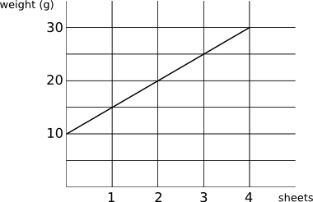The graph shows how the weight of a letter (including the envelope) varies with the number of sheets of paper used.

What is the weight of a single sheet of paper? [1]

**33)** 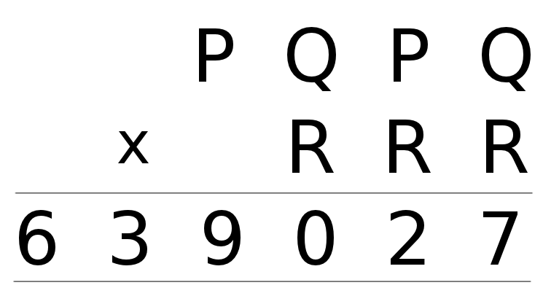What is the value of *P*+*Q*+*R* in the following multiplication?

[1]

END OF TEST