Maths

11+ Entry Examination 2017

60 Minutes

Name: …………………………………..…

Current School: …………………………...

Please read this information before the examination starts.
- You may not use a calculator.
- Protractors and rulers are not required.
- You should attempt all questions.
- There are 39 questions with 50 marks available.
- Use the blank space on the question paper for your workings.
- Make your answers clear.

1) Work out  a) 1.29 $×$ 1000  b)  882  $×$ 56  ____  c) 2 $÷$ 0.1 | [4]
d) 6.31 $-$ 3.2
2) List all the factors of the following number  49 | [1]
3) Order this list from smallest to largest  0.2 5% 3 $\frac{3}{4}$  smallest largest | [1]
4) Calculate the following and give your answer as a fraction in its lowest terms  $\frac{1}{3}+\frac{2}{9}$ | [1]
5) Find the Highest Common Factor of the following pair of numbers  16 and 28 | [1]
6) Find the Lowest Common Multiple of the following pair of numbers  6 and 10 | [1]
7) Write down the digit that means hundred thousands in 2734568 | [1]
8) Write the following improper fraction as a mixed number  $\frac{17}{6}$ | [1]
9) Work out the following:  $\frac{3}{4}$ of 28 | [1]
10) Calculate the following percentage of a quantity  75% of 90 | [1]
11) Convert to a fraction, reduced to lowest terms  5% | [1]
12) Order the following temperatures from coldest to warmest  6, -2, -20, -11 | [1]
13) Order the numbers below from smallest to largest  0.23 0.29 0.289 0.291 0.2  smallest largest | [1]
14) Complete the magic square so that each column and row add up to the same number.  3 -3  1 -1  -1 7 | [1]
15) A whale is 60 metres below sea level. A balloon is directly above the whale and 225 metres above sea level. Find the vertical distance between the whale and the balloon. | [1]
16) Find the value of the formula using the numbers given  $T=7+7x$ when $x=-11$ | [1]
17) Connect the points (3,1), (5,-4), (-5,-4) and (-3,1) to make a quadrilateral.  What shape is it? | [2]
18) I'm thinking of a number. I halve it and get an answer of 10.  What is the number I am thinking of? | [1]
19) I'm thinking of a number. I take away 6 and then divide the result by 12. The answer is 2.  What is the number I am thinking of? | [1]
20) Solve the equation  $4b-9=7$ | [1]
21) Find the area of the shape below.  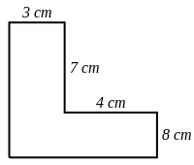 | [1]
22) Find the area of the shape below, drawn on cm square paper.  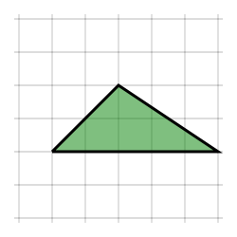 | [1]
23) Find the area of the shape below.  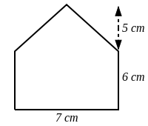 | [1]
24) Calculate the value of $x$ and $y$. (Not drawn to scale – do not use a protractor).  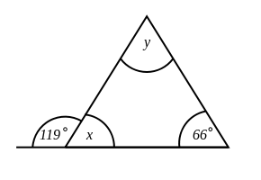 | [2]
25) Which 2 nets can fold to make a cube? | [2]
26) Give ONE letter which touches the vertex (corner) C when folded to make a cube. | [1]
27) Use the bus timetable to answers the questions below.  Place Arrival Time Departure Time  Teignmouth 17:11 17:12  Paignton 17:45 17:52  Dawlish 18:17 18:23  Torquay 18:44 18:46  a) How long is the journey between Teignmouth and Paignton?  b) How long does the bus wait at Paignton? | [2]
28) The line graph below shows the number of times Luca used his van over 7 days.  a) How many times did Luca drive his van on day 1?  b) On which day did he use his van 7 times? | [2]
29) The bar graph below shows the percentage of students who received grades A-D on their last English paper. The class contains 50 students.  How many students received C on their paper? | [1]
30) Using the conversion graph below, convert the following  a) 160 °F to °C b) 65 °C to °F | [2]
31) Olly cycled from his home to the park where he took a rest. He then cycled back home. Below is a distance-time graph for Olly"s complete journey.  Find  a) the time he arrived at the park.  b) the distance to the park.  c) how long he rested at the park. | [3]
32) The digits of Alberta's age are interchanged and 1 is added. The answer is half of Alberta's present age. How old is Alberta?
[1]

33) in the subtraction sum below a, b and c are digits, and a is less than b.
What is the value of c?
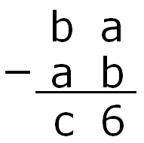
[1]

34) Baby is two years old now and drinks milk by the quarter pint, so we have decided to call her GILL. Getting her to recognise her name proved difficult, so we put the letters G, I, L, L on separate building blocks. She loves arranging them, but rarely gets them in the right order. One day she managed to produce every possible four-letter 'word': LILG is one such. How many different four-letter words did she produce that day?

[1]

35) On my clock's display, the time has just changed to 02:31. How many minutes will it be until all the digits 0, 1, 2, 3 next appear together again?

[1]

36) The ten digits of a digital clock are shown below.
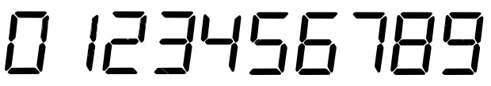
I have a 12 hour digital clock which shows the time, using four digits, on a piece of glass, so it can be seen from both sides. At what time between 3 o'clock and 10 o'clock does the time look the same from both sides?

[1]

37) In the diagram, all the small squares are of the same size.
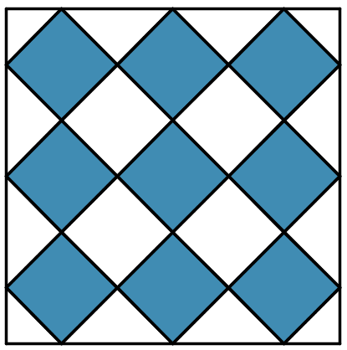
What fraction of the large square is shaded?

[1]

38) Leonard writes down a sequence of numbers. After the first two numbers, each number is the sum of the previous two numbers in the sequence. The fourth number is 6 and the sixth number is 15. What is the seventh number in the sequence?

[1]

39) A book has 89 pages, but the page numbers are printed incorrectly. Every third page number has been omitted, so that the pages are numbered 1,2,4,5,7,8,... and so on. What is the number on the last printed page?

[1]

End of exam

